**ROYAL ONTARIO MUSEUM**

**The first page consists of Home,Login and Signup.**

Header**:** ROYAL ONTARIO MUSEUM

**Company logo**: We can see the Royal Ontario museum logo as ROM and also the navigation

menu which includes (Home, Services, Careers, About Us, and Contact Us)

**Login Form**: Username/email field, password field, login button, forgot password link

**Signup Form**: Name field, email field, password field, confirm password field, signup button  
The login and signup page is shown as below.  
  
  
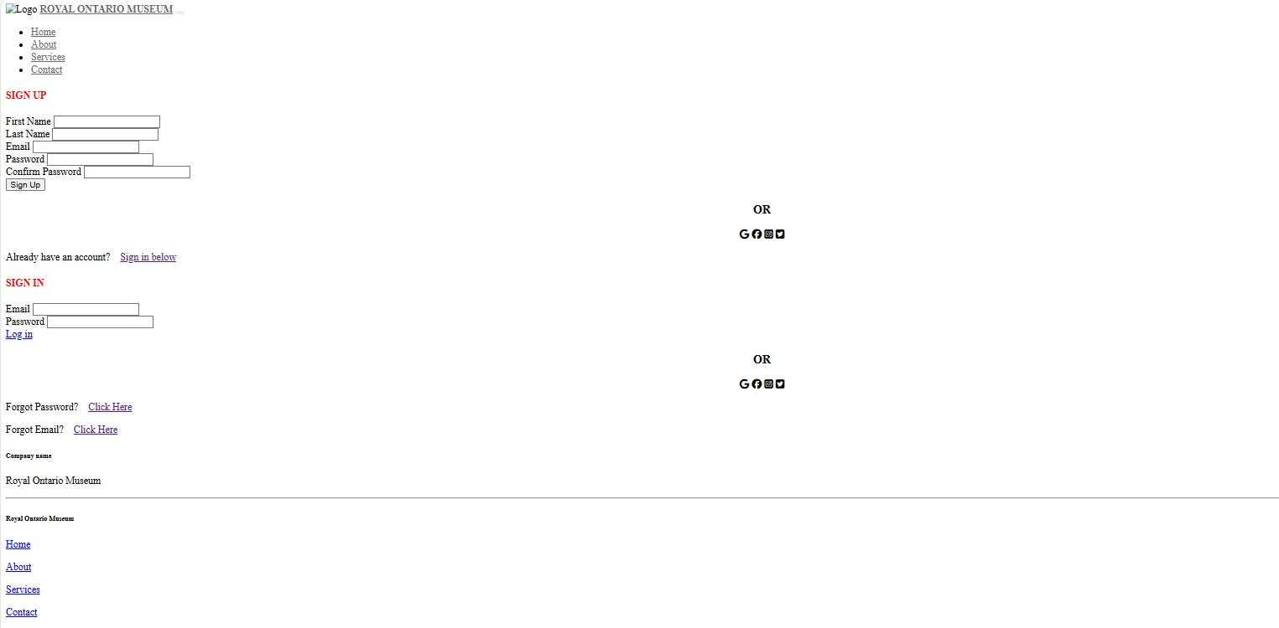  
  
Next page includes useful links such as careers, privacy policy, accessibility policy and help. It also contains contact numbers overseas and in Canada. If they need support via chat and tagging on social media platforms.  
  
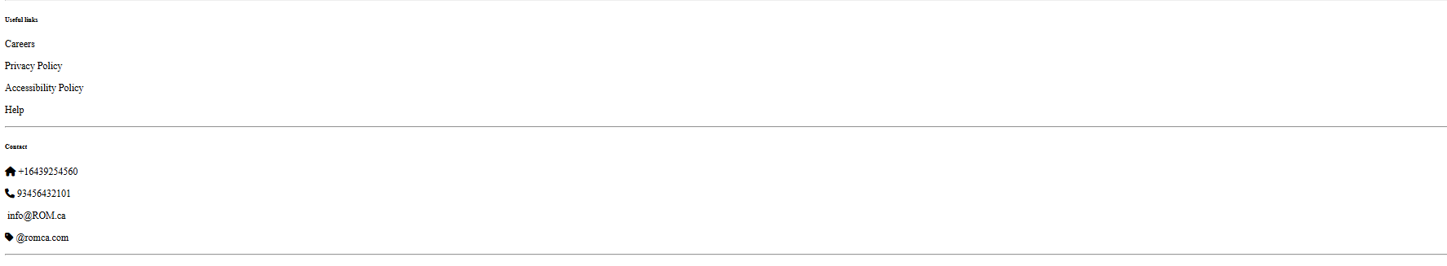  
  
Next page includes explore, exhibitions, events, plan your visit and about. Also it displays show featured exhibitions, 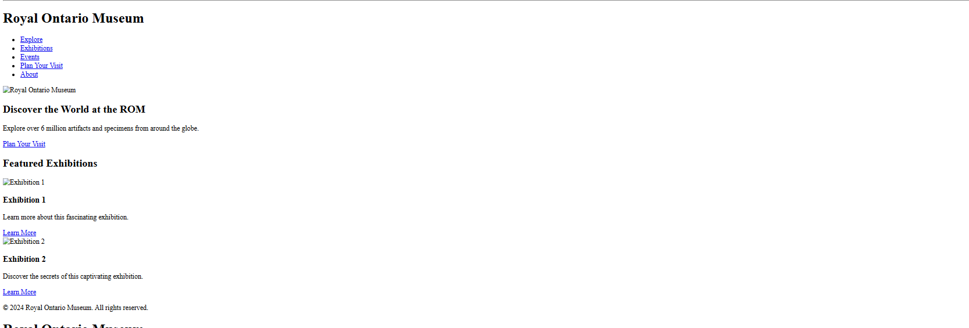  
  
  
  
  
**CHALLENGES FACED:**  
The main challenges faced while doing this are not able to display all the images, all the content is not fitted in one page. Redundancy over the webpages.